Books of my Bookshelf

Product Brief and Architecture Use Case

Mickie Leonard

6/29/25

v. 1.07

About me

An explorer at heart, I love nothing more than to learn a new skill, answer a question from my team, or explore a new concept.

Self-taught VBA and SQL developer, now certified Python developer. Working on my AWS Solutions Architect - Associate certification, which has brought me full circle with expertise there was not enough time to learn in my last role.

I have a passion for exploring digital products and making them more user friendly. Many years of working with internal and external clients has honed my ability to speak the business language the end user understands and then translate that to the technical language developers need.

Inspired by the different ways that Agile and Waterfall methods can be used to deliver value.

I believe in my teams and take the time to learn who they each are and recognize how they help the organization succeed. We can do nothing without the people who do the work.

Project goal

* Demonstrate proficiency in product processes and documentation for a new application.
* Demonstrate proficiency in python development.
* Demonstrate proficiency in architecture creation to suite client needs.

Table of Contents

About me 2

Document goal 2

Product Brief 5

Company Profile 5

Application Summary 5

Feature 1: HTTPS company page (pre-login content) 6

Feature #: HTTPS company page (pre-login integration) 7

Feature 2: Website enablers 8

Feature 3: Secure Log-in 9

Feature 4: Home page 10

Feature 5: Bookshelf 11

Feature 6: Search results and clickable content 12

Feature 7: Gamify 13

Feature 8: Mobile application 14

Feature 9: Ad Spaces 15

Architectural Use Case 16

RFP 16

Additional known details 16

Proposal 16

Appendix 17

Flows 17

Anticipated User Experience Flow 17

Sitemap 18

Templated Designs 19

Miro Link 19

Desktop 19

Tablet 20

Mobile 20

Sample Designs with URL 21

Corporate 21

/login/ 22

/home/ 23

/profile/ 24

/bookshelf/ 24

/search-results/ 26

/book-name/ 27

/author-name/profile/ 27

/awards/ 28

Feature #: Short Description 29

Product Brief

Company Profile

A new start-up with a small staff. Budget is limited as well is expertise in architectures and systems.

Application Summary

A new application designed to allow users to track their reading habits and earn virtual awards.

Feature 1: HTTPS company page (pre-login content)

Create a new company landing page with an HTTPS landing page and information pages

**Problem Statement:** Company landing pages should be included in the HTTPS encryption process to ensure entire site remains secure, pre and post log-in.

**Feature Hypothesis:** Certain pages have no secure content but should be created under an HTTPS URL. Any navigation beyond those pages will redirect to login before navigating to the requested page.

**Objectives:**

1. Create a static company landing page.
2. Create a set of static application information pages.

**Designs:**

* booksofmybookshelf.com
  + /about-us/
  + /contact-us/
  + /sitemap/
  + /help/

Feature #: HTTPS company page (pre-login integration)

Integrate static pre-login content pages to redirect to login if user selects navigation that is post log-in

**Problem Statement:** Company landing pages should be included in the HTTPS encryption process to ensure entire site remains secure, pre and post log-in.

**Feature Hypothesis:** Certain pages have no secure content but should be created under an HTTPS URL. Any navigation beyond those pages will redirect to login before navigating to the requested page.

**Objectives:**

1. Integrate each page to redirect to the log-in flow if any post log-in navigation options are chosen.

**Designs:**

* booksofmybookshelf.com
  + /about-us/
  + /contact-us/
  + /sitemap/
  + /help/

Feature 2: Website enablers

Create the enabling features on the back-end to support the website.

**Problem Statement:** A website build requires certain build features that do not add value, however, should be considered product enablers.

**Feature Hypothesis:** Identify non-value add work that enable the website and prioritize for creation.

**Objectives:**

1. Review previously identified features.
2. Document any underlying features that would enable those features to work seamlessly.
3. Add click tracking to all buttons and links to observe user behavior.

**Designs:**

N/A

Feature 3: Secure Log-in

Create a new application with a secure log-in process.

**Problem Statement:** Unsecured applications create a security risk for both the company and for users, limiting the adoption of the new application.

**Feature Hypothesis:** Demonstrating a secure log in process will allow the company to build engagement with users.

**Objectives:**

1. Create a secure log-in page with a secure back-end.
2. Require users to use strong passwords (NIST compliant) to log into the application.
   1. Length >=8 and <= 64.
   2. No character restrictions, such as 1 capital letter, 1 special character, etc.
   3. Allow ASCII and Unicode characters.
   4. Create a maintainable blocked password list to prevent common or compromised passwords.
   5. Non-expiry password
3. Require users to use multi-factor authentication (MFA) methods to further secure their account.
4. Give users the ability to change profile information, still requiring strong passwords and MFA
5. Give users the ability to recover lost Usernames and Passwords using a secure code sent to user determine MFA.

**Designs:**

* /login/
  + /login/register/
  + /login/forgot-username/
  + /login/forgot-username/recovery
  + /login/forgot-password/
  + /login/forgot-password/recovery/
* /profile/

Feature 4: Home page

Create a user-friendly landing page for easy navigation to each feature.

**Problem Statement:** Cluttered landing pages create distractions for users and limit engagement in each feature.

**Feature Hypothesis:** Creating a clear, concise, and user-friendly landing page will increase engagement and allow the company to differentiate the experience from other applications.

**Objectives:**

1. Provide direct navigation to each feature with descriptive buttons that drive users to action.
2. Create a navigation hamburger menu to allow navigation from anywhere.

**Designs:**

* /home/

Feature 5: Bookshelf

Create a private library for each user.

**Problem Statement:** A core component of applications of this type is the virtual bookshelf that users can personalize and securely store information about their books and reading habits.

**Feature Hypothesis:** Having a multi-layered library system with unique features will increase usage and readership.

**Objectives:**

1. Unique standard bookshelves.
2. Provide a variety of standard tags and the ability to create custom tags, all of which can be searched and attached to books.
3. Reporting of the content at the book level of reading events, e.g., start date, end date, rating, review.

**Designs:**

* /bookshelf/
  + /bookshelf/tbr/
  + /bookshelf/library/
  + /bookshelf/reading/
  + /bookshelf/read/
  + /bookshelf/dnf/

Feature 6: Search results and clickable content

Create pages to show the search results, including ability to click on book or author name.

**Problem Statement:** Finding books by book-name and/or author name is vital to the ease of use of the tracking mechanisms for the product.

**Feature Hypothesis:** A dynamic search results process should be built which integrates with the book-name and author-name pages and underlying databases.

**Objectives:**

1. On click navigation to a book included in a library or via search.
   1. Track reading events, e.g., start date, end date, rating, review.
2. On click navigation to an author included in a library or via search.
   1. Provide the ability to follow an author.
3. Create search result landing page

**Designs:**

* /book-name/
* /author-name/profile/
* /search-results/

Feature 7: Gamify

Gamify reading and application experience.

**Problem Statement:** Users are more likely to be engaged in the application and reading when the experience provides a game-like atmosphere.

**Feature Hypothesis:** Create differentiation by having a variety of contests and awards for users to track against (passively and actively).

**Objectives:**

1. Create a library of contests and awards based on reading behavior.
2. Create a library of contests and awards based on application utilization.
3. Track status of awards passively against a prebuilt goal.
4. Track status of awards passively against a actively chosen goal.

**Designs:**

* /awards/

Feature 8: Mobile application

Create a mobile version of all application flows and pages.

**Problem Statement:** Users are more likely to be engaged in the application via a mobile platform. Should the mobile application build go first?

**Feature Hypothesis:** Create differentiation by having a mobile version of all desktop components.

**Objectives:**

1. Replicate user flows on a mobile platform.
2. Integrate mobile page versions to the applicable back-end resource.

**Designs:**

Attached to all desktop pages.

Feature 9: Ad Spaces

To be profitable as a company, ad spaces will be present on all screens.

**Problem Statement:** Companies must be profitable to continue to function.

**Feature Hypothesis:** Create ad space that can be sold to fund the ongoing operations.

**Objectives:**

1. Create ad spaces on each page.
2. Ensure secure API/endpoint integration to any external providers of ad content.

**Designs:**

Attached to all pages.

Architectural Use Case

RFP

Client has requested an architectural proposal for a cloud-native infrastructure for a new application. They expressed that they have a limited number of engineers and their experience on the infrastructure side of the house is limited. They also expressed that since this is a new start-up their budget is limited.

Additional known details

Code base

* Front-end: Flask
* Back-end: Python

Traffic

Expected to be light as the application is introduced to the market.

Proposal

Appendix

Flows

Anticipated User Experience Flow

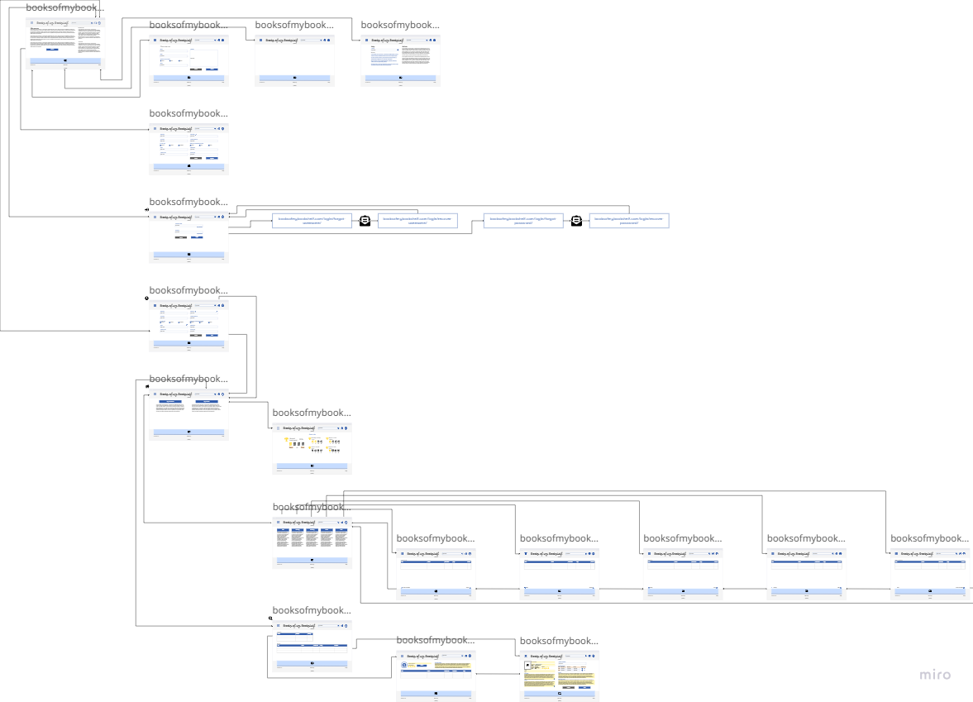

Sitemap

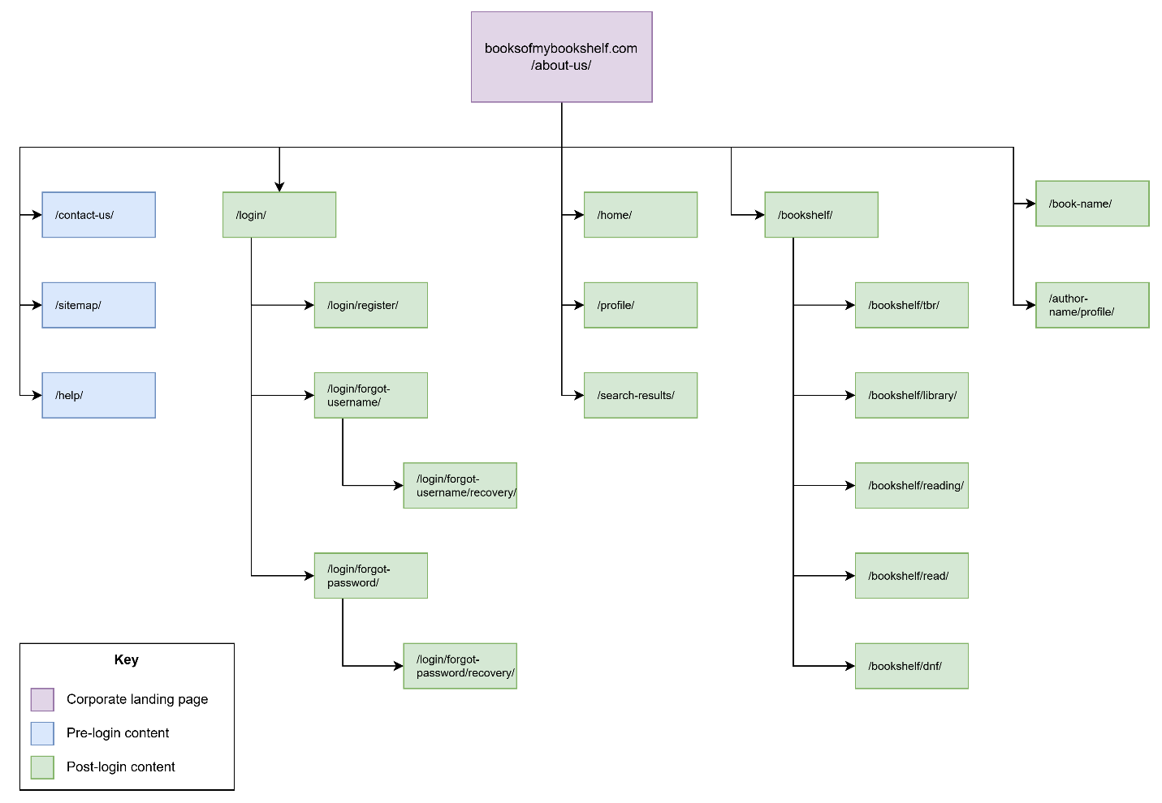

Templated Designs

**Note:** I am only a pretend designer. This exercise is to help visualize what the screens and functions could look like to ensure features and architecture truly fit the use cases.

[Miro Link](https://miro.com/app/board/uXjVIjDo4AY=/?share_link_id=484501531224)

Desktop

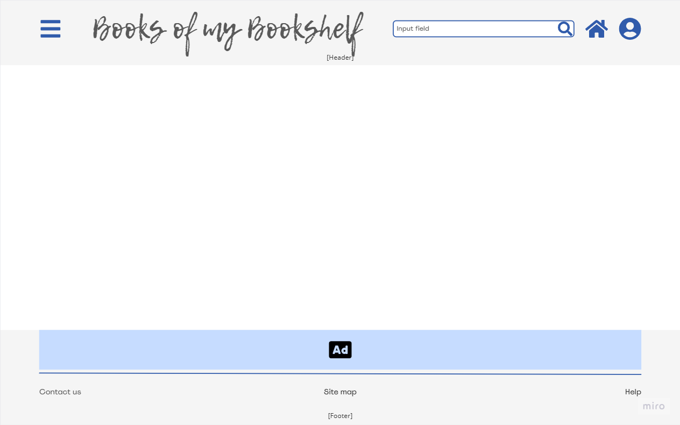

Tablet



Mobile



Sample Designs with URL

Corporate

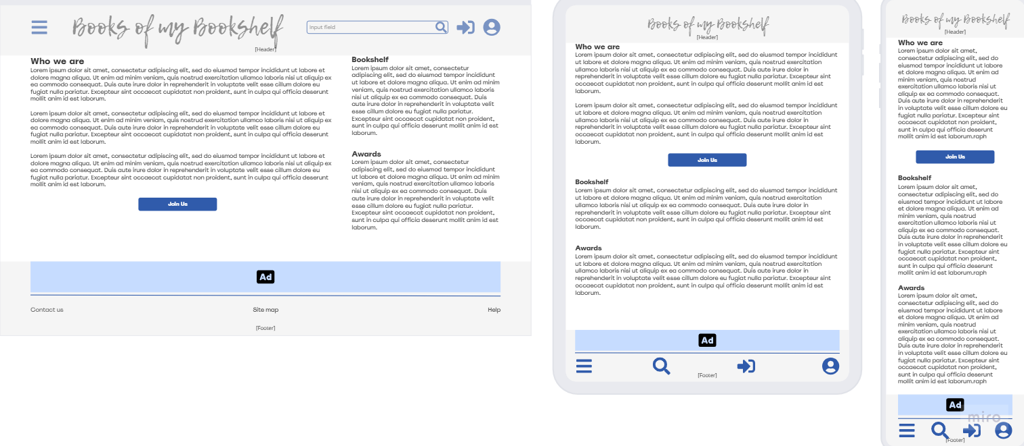

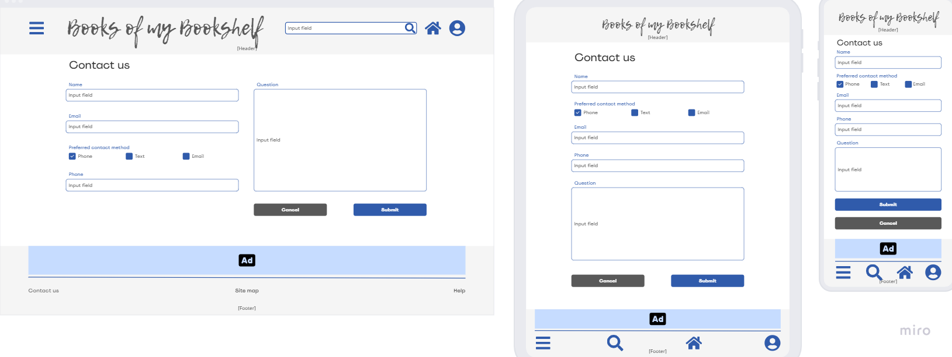

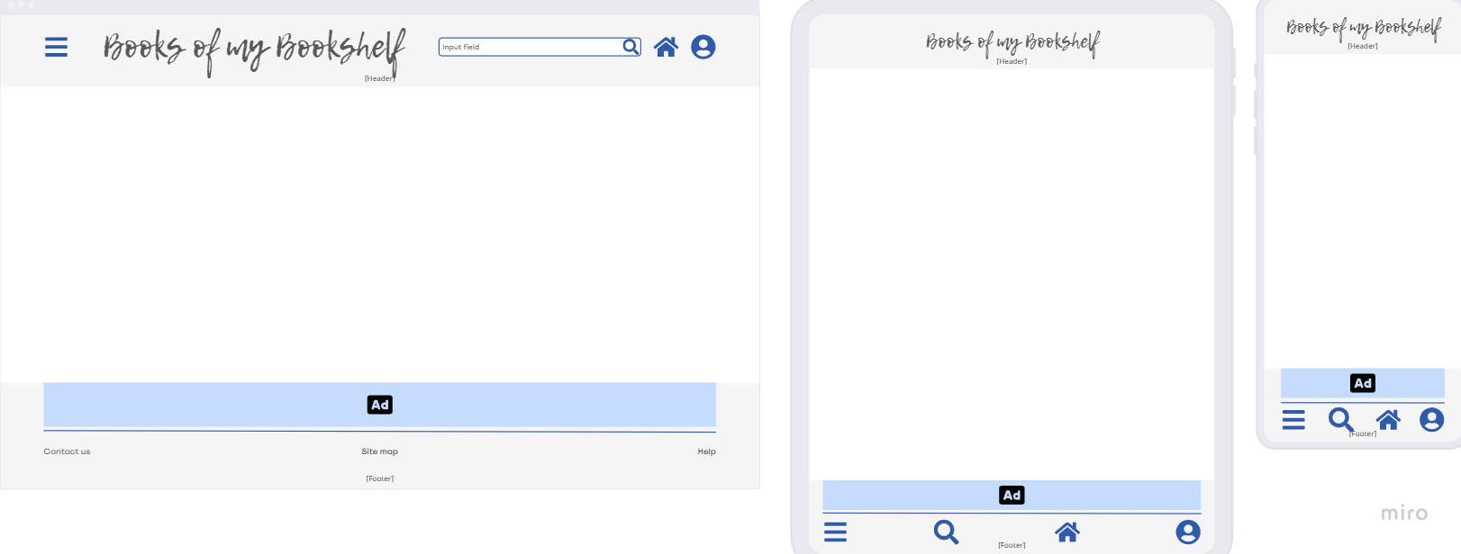

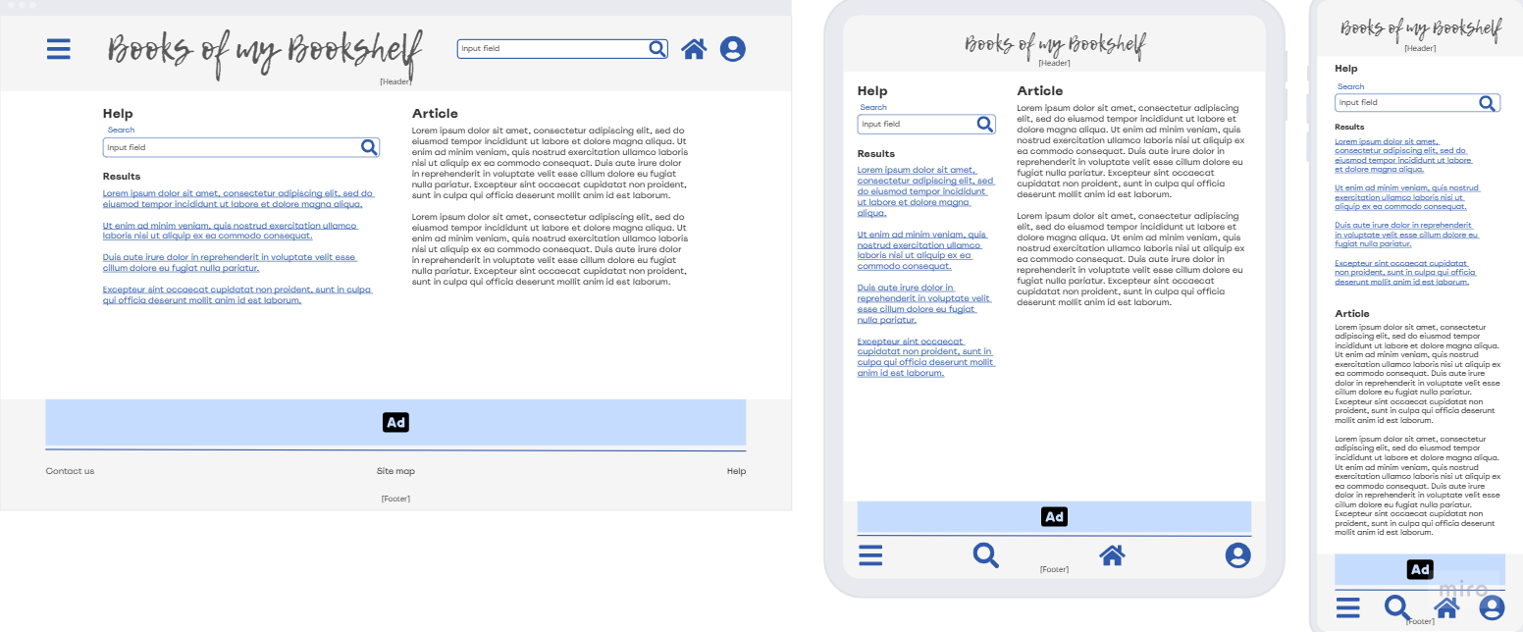

/login/

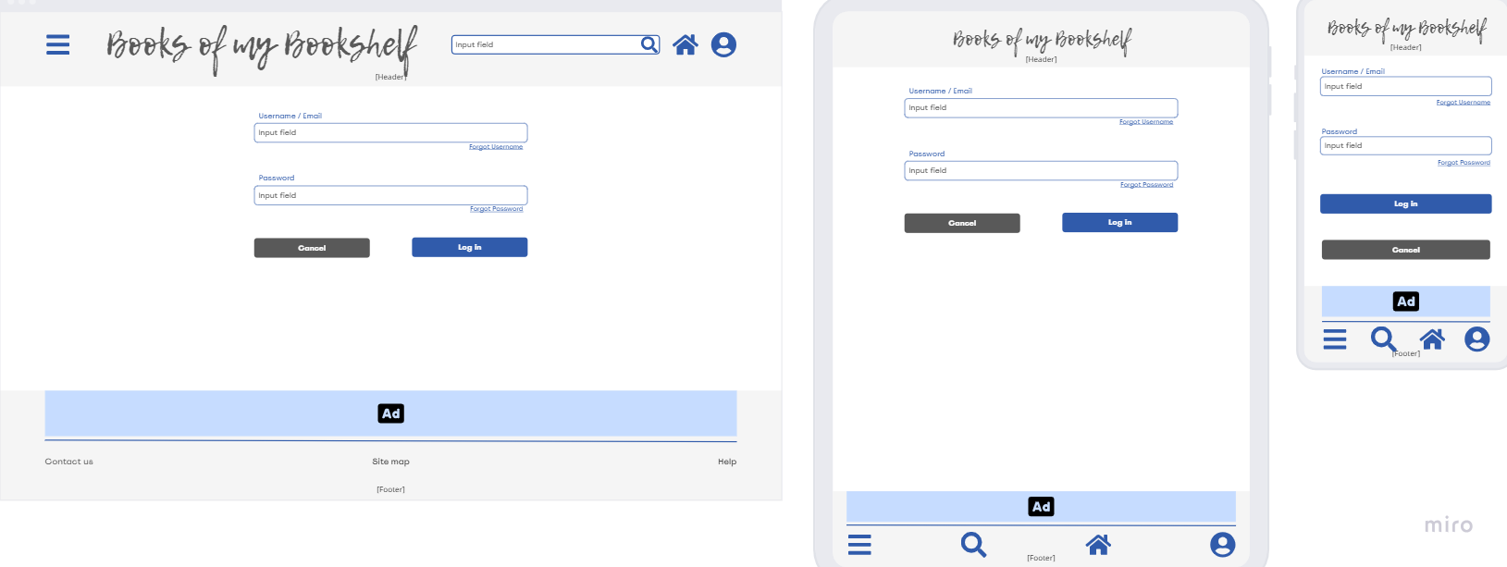

/login/forgot-username/

/login/recover-username/

/login/forgot-password/

/login/recover-password/

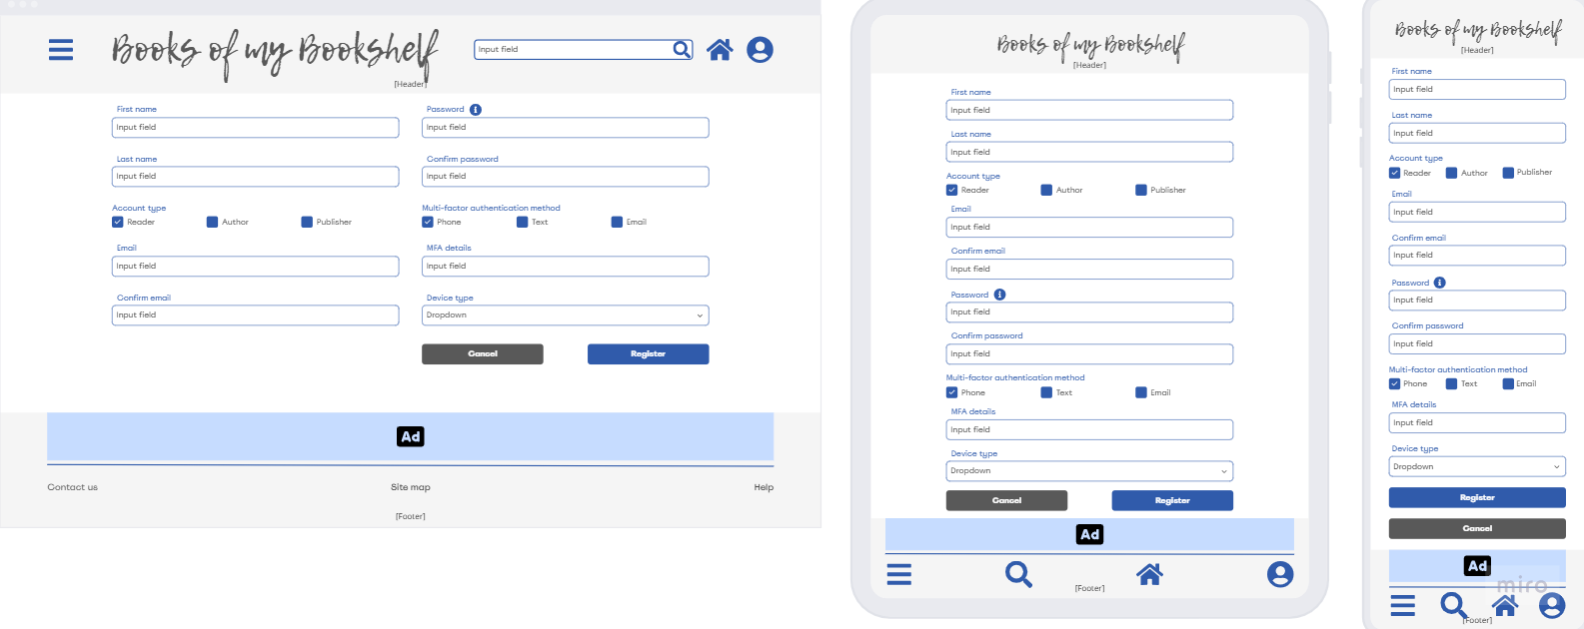

/home/

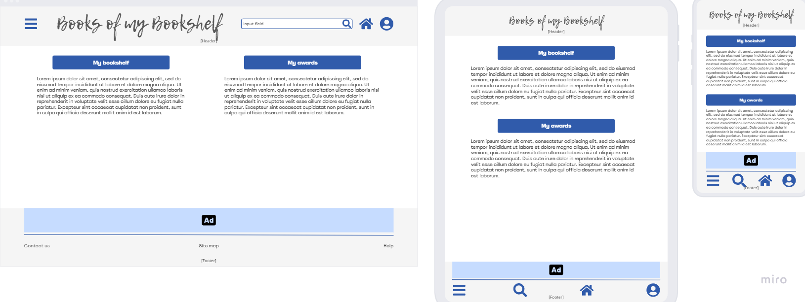

/profile/

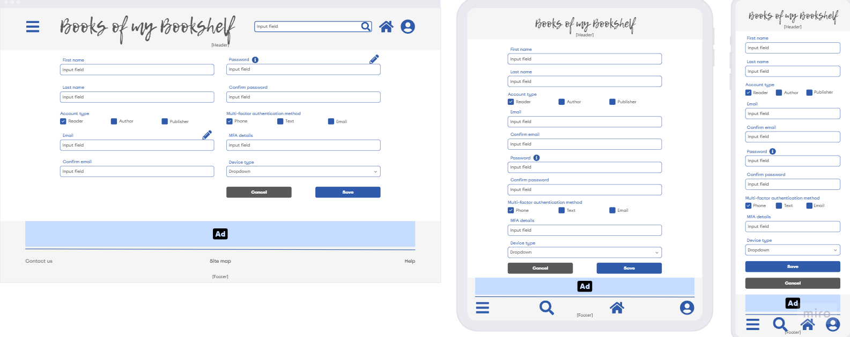

/bookshelf/

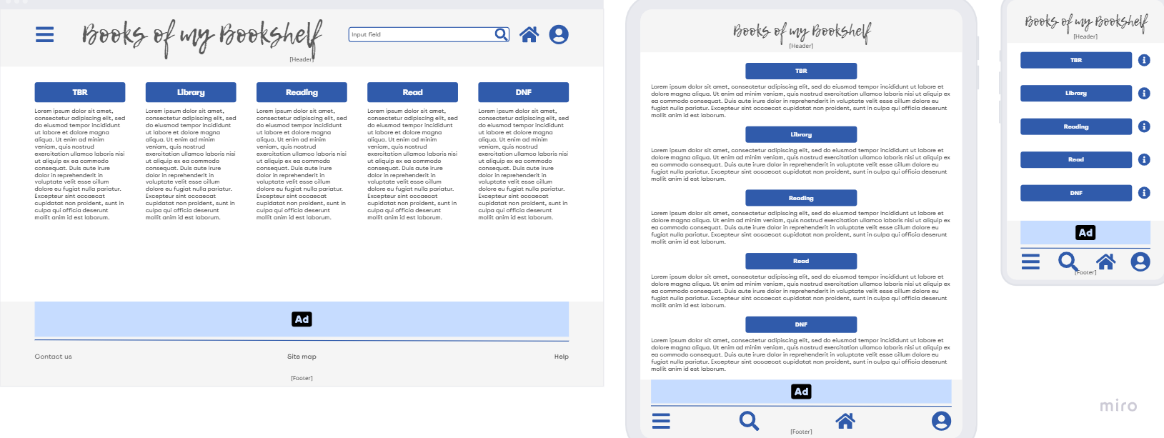

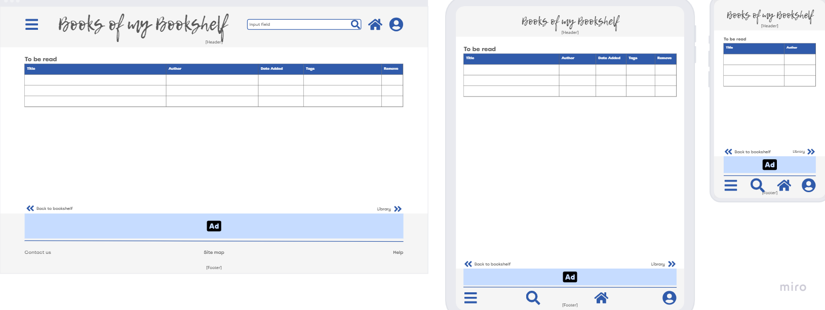

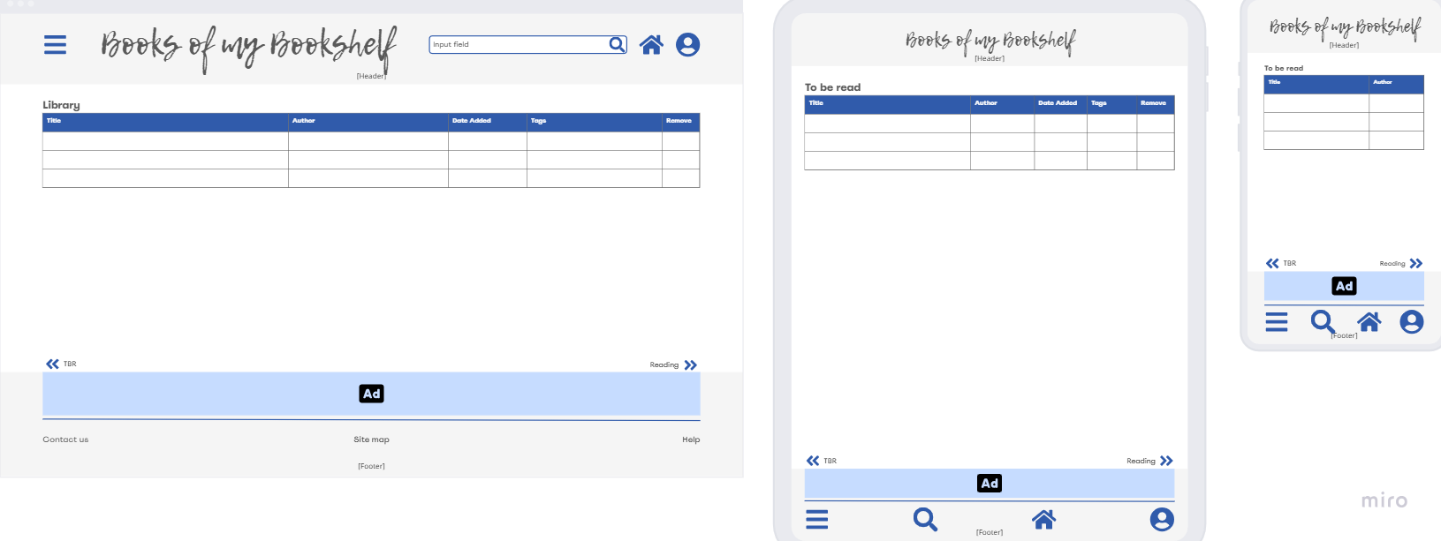

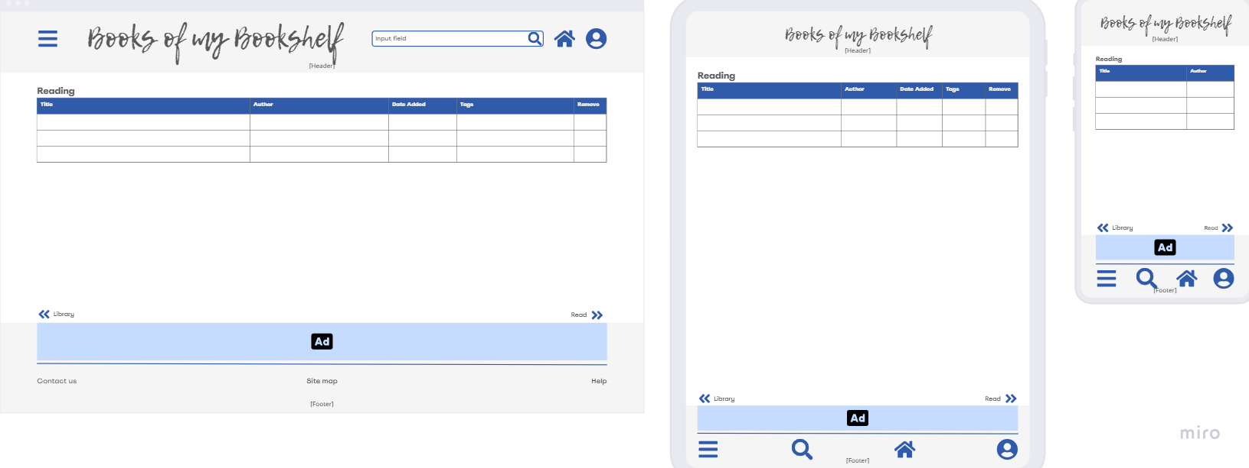

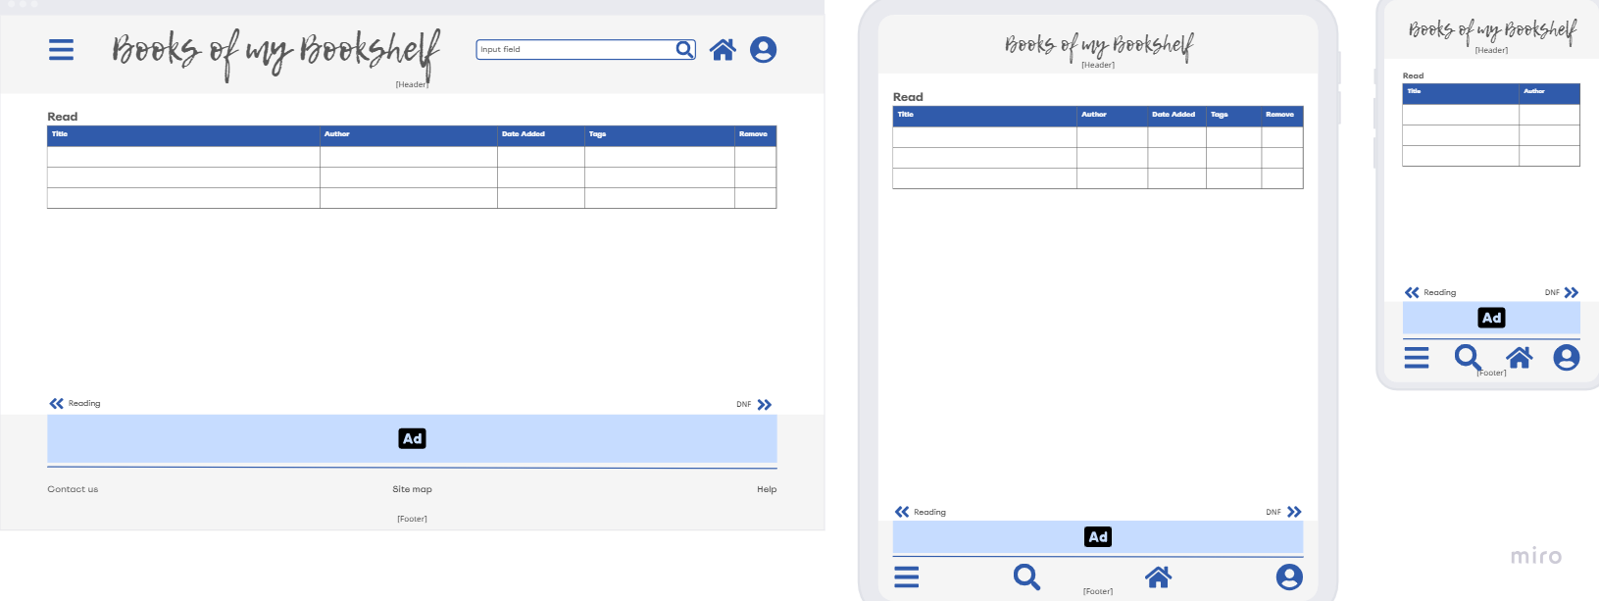

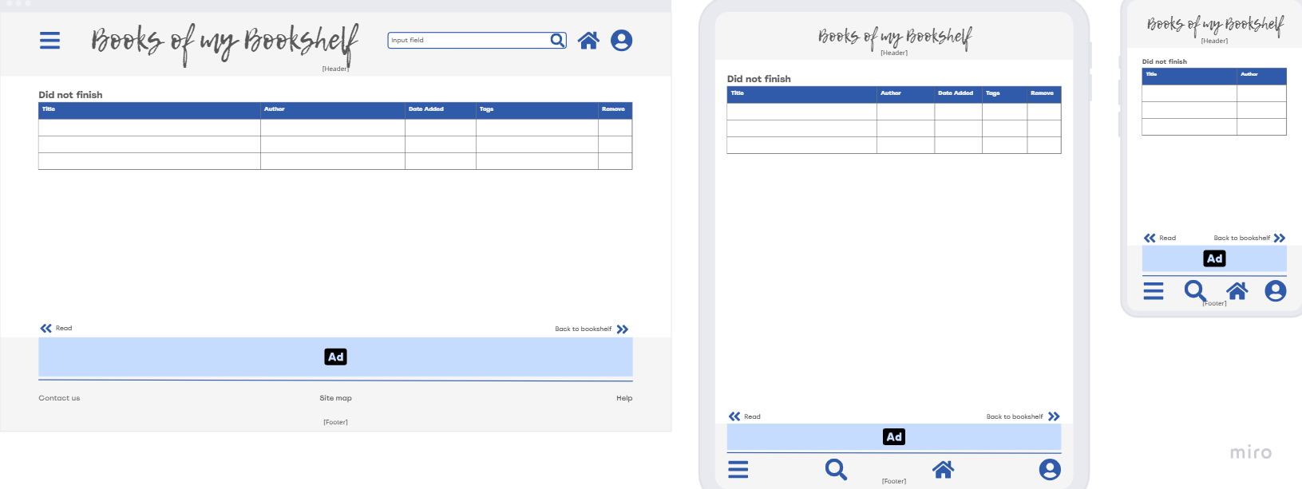

/search-results/

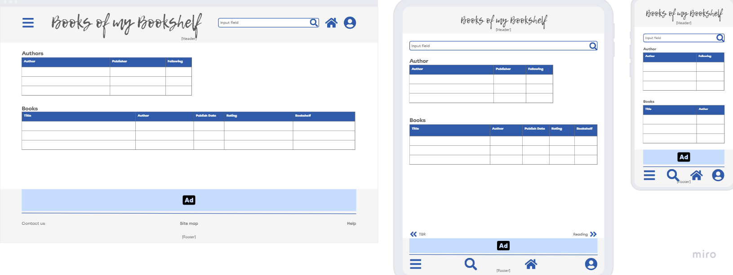

/book-name/

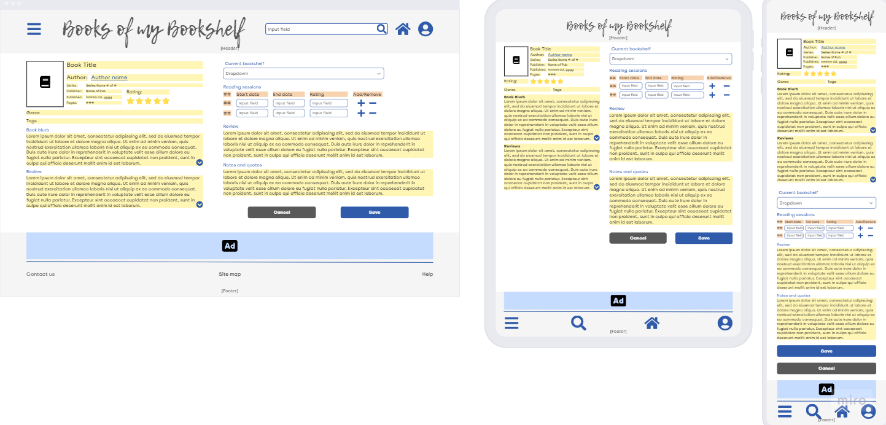

/author-name/profile/

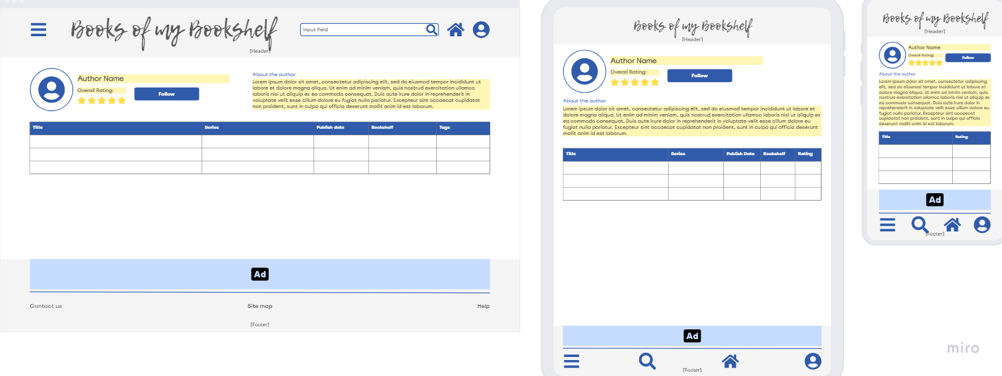

/awards/

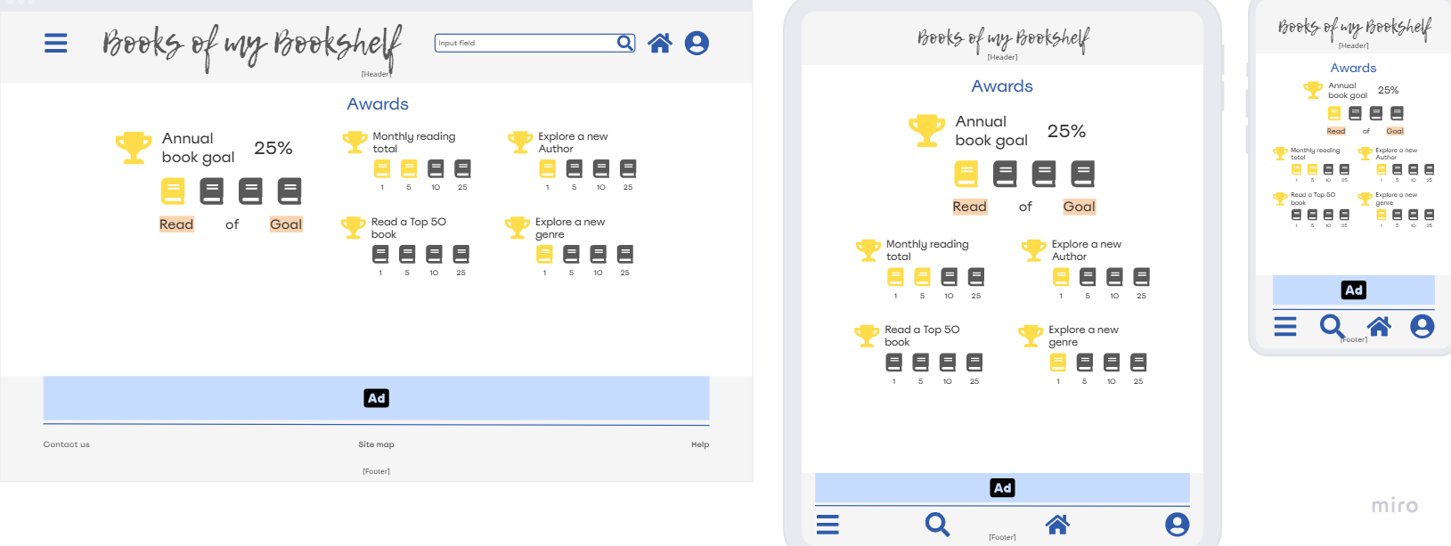

Feature #: Short Description

Long description

**Problem Statement:** problem to be addressed by the feature

**Feature Hypothesis:** Testable hypothesis that supports resolution of the problem statement

**Objectives:**

1. An objective
2. Another objective

**Designs:**

N/A